Glossary and Bibliography To-Do List

General note: whenever you finish working on a glossary file, you need to reformat it. This is something we only do with these XML files. You can do this as often as you like. It just lays out the text properly on the screen. I’ve done it for all your files and put updates in GitHub.

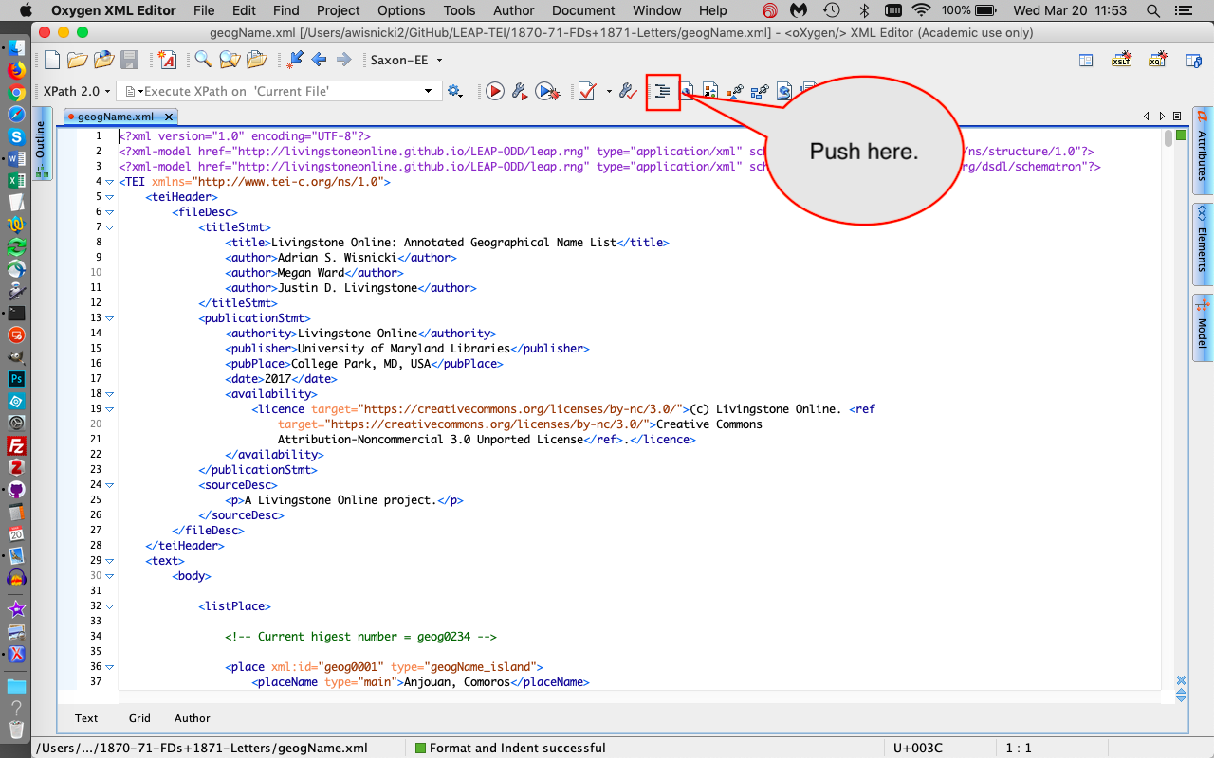

1. Done. Review ethnic-group.xml and geogName.xml. (Optional, since they’ve been proofed by Lizzie)

If you do look at these notes or any of the other categories (which you read previously), note the following:

* Where Livingstone uses a term in MT that is different from the normalised form of the name provided in the note, I’ve begun with the following wording: ‘Called ... by Livingstone’
* Where Livingstone uses the normalised term, but also another term (or a range of others), I’ve begun the note with the wording: ‘Also called ... by Livingstone’
* Where the term in the note was very famously historically called something else (normally a place name), I’ve used the wording: ‘Known historically as …’
* Where the term in the note also has another name by which it is commonly known, I’ve used the wording: ‘Also known as …'

The first two are used more often that the latter.

Thanks for doing this normalization. As it’s now consistenly across all the files, and you have a good system for it, we’re good.

I just took a quick look at these two files, mainly checking where you’d changed what I had previously. Re: ethnic group, since you’ve added 75 new ones (!) I’d strongly urge you to ask Jared to give your definitions a once over. He’s local to the review, and having his eyes go over it wouldn’t hurt. I don’t need to be involved, so it’d just be a matter of him review, then you incorporating any suggestions.

1. Done. Review my normalisation of your glossary notes in the following categories: ethnic-group.xml; geogName.xml; orgName.xml; people.xml; region.xml; and settlement.xml (Essential)

Note that I changed Kololo to Makololo, Kwena to BaKwena, Tlhpaing to BaTlhaping, and Balunda to Lunda to bring all the notes into line. I also changed Zambesi to Zambezi, capitalised the ‘e’ in Zambezi Expedition, hyphenated directions (i.e. south-east), and used lower case for ‘east Africa’, ‘west Africa’ and ‘central Africa’. These amount to very few changes, but feel free to reject any that you want.

All accepted. It almost killed me, but I’ve now also carried these over throughout the site!

1. Done. Review glossary bibliography, which is shared with you as a googledoc and also in Github (Optional) Ack! It’s definitely not in my heart just now to review a 26-page bibliography in detail. In running my eye over the whole thing, I didn’t note anything amiss and bless you for putting all those links into Google docs. Two questions: Has Lizzie (or someone else – maybe you can bribe your father?!) reviewed this? Did you put this in Zotero by any chance? I ask about the latter because in working on my book, I did put everything into Zotero and found it was quite helpful in sorting the biblio data in various ways and I did find a lot of errors. For adding links to the site (internal to LO and external to other sites), see the new section of the Manual “Using Relative Links for Livingstone OnlinePages.”
2. Give me the go-ahead to integrate the ethnic-group and geogName notes (i.e. XML IDs) into the XML transcription files (Essential – I assume I can go ahead and do this, but confirm just in case there are any problems). I think you can do this, since I’ve now finished reviewing these files.
3. Give me the go-ahead to compile all my glossary notes into a word doc, in preparation for upload to the website (Essential) I think you can do this, since I’ve now finished reviewing these files.
4. Justin to do. Let me know if you have any tips on this. I’m currently just planning on a laborious copy and paste exercise…

I will help you with this. As a first step, simply copy over the relevant text (including tags – i.e., don’t edit anything; just copy as is) into a single text file (I prefer a TXT file rather than Word, unless your file includes italics and other formatting, in which case use Word) that is broken down into sections, modeling the categories on the following: <http://livingstoneonline.org/spectral-imaging/glossary-key-terms-in-livingstones-manuscripts-1870-71>

1. To do: Justin. Give me the go-ahead to integrate the glossary bibliography into the complete project bibliography as a word doc, in preparation for upload to the website (Essential) I believe this refers to #3 above? If so, then yes go for it! Also, when you’re done, just as a precaution I suggest you go to “source” view in the LO drupal form, select all the code, then copy it into a text file on your computer. This is just being extra cautious, but hey this is 26 pages of integration! Presumably you’re not having a separate glossary bibliography. Is that right? I would think that the main one is enough as you can just point the glossary to that. I’ve now created this bibliography, as you know, and it’s awaiting your review.
2. Done. Upload all the glossary xml files to the website (Essential – but best to wait until I’ve compiled the glossary word doc, in case I spot any final typos)

The glossary files are:

ethnic-group.xml

geogName.xml

orgName.xml

people.xml

region.xml

settlement.xml

Note that these all the categories I’ve written notes forI

Including the refomatted versions. I can update this again as needed going forward.

1. To do: Justin. Put complete glossary notes [? – please confirm this word, as I want to make sure this corresponds to #5 and #6 above] (compiled by me as word doc) into Key Terms section of the MT edition (Essential – I can do this once the section has been created). I believe this is linked to #5 and #6 above? If so, then the first step is for you to compile everything per my note above, then send to me, and I’ll help you with this. I’ve gone ahead and created a minimal version of the section page for you: <http://livingstoneonline.org/in-his-own-words/missionary-travels-manuscript/glossary-key-terms-in-the-missionary-travels-manuscript> It’s unpublished at present, and there’s nothing you need to at this point other than a quick review, but it’s now here when you need it. Note that that title was slightly on the long side, so I replaced “Livingstone’s” with “the.” I know that this doesn’t’ 100% correspond with the other glossary now, but that’s OK with me!
2. To do: Justin Put revised complete project biblio (compiled by me as word doc) into Project Bibliography section of the MT edition (Essential – I can do this). Go for it!
3. To do: Kate and Justin. Upload the xml transcription files with tooltips integrated (Essential – but not yet ready until Kate completes the work).

The files to be replaced are:

liv_000099_TEI.xml

liv_000100_TEI.xml

liv_000101_TEI.xml

liv_000102_TEI.xml

liv_000103_TEI.xml

liv_000104_TEI.xml

liv_003010_TEI.xml

For now, I’ll be putting the latest versions of the files up this week. Then, when you add tooltips, etc. I can do it again. So this is a task to be done later.